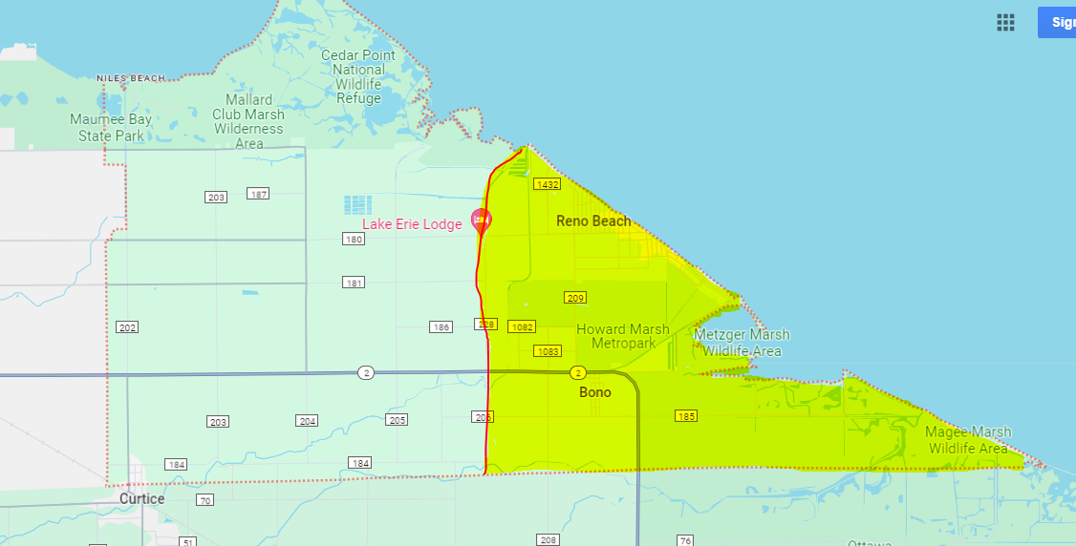

Red line indicated Teachout Rd – everything to the right is considered Thursday (highlighted in yellow)
This includes Bono down to Brown Rd.

Left of the red line is Friday Services – all noted in the light green color.

